**Android Application that implements Multi threading**

Aim:

        To develop a Android Application that implements Multi threading.

Procedure:

Creating a New project:

* Open Android Studio and then click on **File -> New -> New project.**

[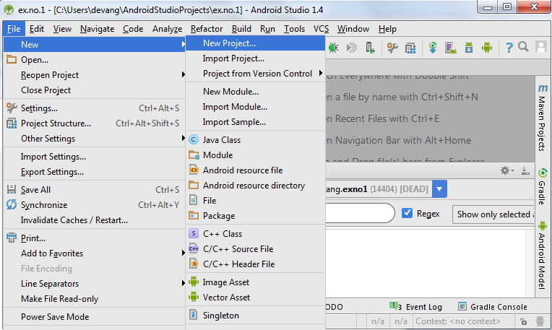](https://codingconnect.net/wp-content/uploads/2016/02/new-project.png)

* Then type the Application name as “**exno7″** and click **Next.**
* Then select the **Minimum SDK** as shown below and click **Next**.
* Then select the **Empty Activity**and click **Next.**
* Finally click F**inish**.
* It will take some time to build and load the project.
* After completion it will look as given below.

Designing layout for the Android Application:

* Click on **app -> res -> layout -> activity_main.xml**
* Now click on **Text** as shown below.

Experiment 7-

**MainActitivty.java**

package com.example.exno7;  
  
import android.os.Bundle;  
import android.os.Handler;  
//import android.support.v7.app.AppCompatActivity;  
import android.util.Log;  
import android.view.View;  
import android.widget.Button;  
  
import androidx.appcompat.app.AppCompatActivity;  
  
public class MainActivity extends AppCompatActivity {  
 private static final String *TAG* = "MainActivity";  
  
 private Button buttonStartThread;  
  
 private Handler mainHandler = new Handler();  
  
 private volatile boolean stopThread = false;  
  
 @Override  
 protected void onCreate(Bundle savedInstanceState) {  
 super.onCreate(savedInstanceState);  
 setContentView(R.layout.*activity_main*);  
  
 buttonStartThread = findViewById(R.id.*button_start_thread*);  
 }  
  
 public void startThread(View view) {  
 stopThread = false;  
 ExampleRunnable runnable = new ExampleRunnable(10);  
 new Thread(runnable).start();  
 /*  
 ExampleThread thread = new ExampleThread(10);  
 thread.start();  
 */  
 /*  
 new Thread(new Runnable() {  
 @Override  
 public void run() {  
 //work  
 }  
 }).start();  
 */  
 }  
  
 public void stopThread(View view) {  
 stopThread = true;  
 }  
  
 class ExampleThread extends Thread {  
 int seconds;  
  
 ExampleThread(int seconds) {  
 this.seconds = seconds;  
 }  
  
 @Override  
 public void run() {  
 for (int i = 0; i < seconds; i++) {  
 Log.*d*(*TAG*, "startThread: " + i);  
 try {  
 Thread.*sleep*(1000);  
 } catch (InterruptedException e) {  
 e.printStackTrace();  
 }  
 }  
 }  
 }  
  
 class ExampleRunnable implements Runnable {  
 int seconds;  
  
 ExampleRunnable(int seconds) {  
 this.seconds = seconds;  
 }  
  
 @Override  
 public void run() {  
 for (int i = 0; i < seconds; i++) {  
 if (stopThread)  
 return;  
 if (i == 5) {  
 /*  
 Handler threadHandler = new Handler(Looper.getMainLooper());  
 threadHandler.post(new Runnable() {  
 @Override  
 public void run() {  
 buttonStartThread.setText("50%");  
 }  
 });  
 */  
 /*  
 buttonStartThread.post(new Runnable() {  
 @Override  
 public void run() {  
 buttonStartThread.setText("50%");  
 }  
 });  
 */  
 runOnUiThread(new Runnable() {  
 @Override  
 public void run() {  
 buttonStartThread.setText("50%");  
 }  
 });  
 }  
 Log.*d*(*TAG*, "startThread: " + i);  
 try {  
 Thread.*sleep*(1000);  
 } catch (InterruptedException e) {  
 e.printStackTrace();  
 }  
 }  
 }  
 }  
}

**exno7//MainActivity.java**

package com.example;  
  
import android.app.Activity;  
  
public class MainActivity extends Activity {  
}

**activity_main.xml**

<?xml version="1.0" encoding="utf-8"?>  
<LinearLayout xmlns:android="http://schemas.android.com/apk/res/android"  
 xmlns:tools="http://schemas.android.com/tools"  
 android:layout_width="match_parent"  
 android:layout_height="match_parent"  
 android:gravity="center"  
 android:orientation="vertical"  
 tools:context="com.example.MainActivity">  
  
 <Switch  
 android:layout_width="wrap_content"  
 android:layout_height="wrap_content"  
 android:layout_marginBottom="16dp"  
 tools:ignore="UseSwitchCompatOrMaterialXml" />  
  
 <Button  
 android:id="@+id/button_start_thread"  
 android:layout_width="wrap_content"  
 android:layout_height="wrap_content"  
 android:onClick="startThread"  
 android:text="Start"  
 tools:ignore="HardcodedText,UsingOnClickInXml" />  
  
 <Button  
 android:layout_width="wrap_content"  
 android:layout_height="wrap_content"  
 android:onClick="stopThread"  
 android:text="Stop"  
 tools:ignore="UsingOnClickInXml" />  
  
</LinearLayout>

**Output-**